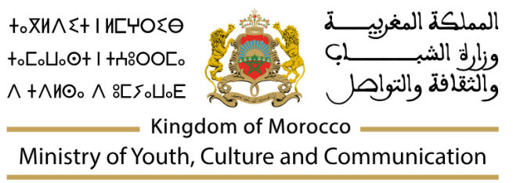


MEMORANDUM OF UNDERSTANDING

Between

The Ministry of Youth, Culture and Communication of the Kingdom of Morocco
- MJCC -

And

Pixoul Gaming

The Ministry of Youth, Culture and Communication of the Kingdom of Morocco, represented by the Minister, M. Mohamed Mehdi BENSAID, Minister of Youth, Culture and Communication

On the one hand,
And
Pixoul Gaming, an immersive gaming, esports, and digital entertainment company, represented by ----, CEO-----
On the other hand,
Hereinafter jointly referred to as "the Signatories",

Considering :
- The strategic importance of developing the gaming industry in Morocco and the Kingdom’s desire to establish a sustainable ecosystem that fosters investment and job creation;
- Morocco's ambition to attract foreign investment through co-production frameworks in the gaming sector;
- Pixoul Gaming's growth strategy to expand its international presence, particularly in Africa;
- Pixoul Gaming's expressed interest in contributing to the development of the gaming industry ecosystem in Morocco.

Convinced of the relevance of strengthening bilateral cooperation in the gaming ecosystem through training, innovation, investment, and exchange of expertise, with a particular focus on youth empowerment, digital skills development, cultural innovation, and entrepreneurship,

The Signatories declare their intention to cooperate on the following points:

Pixoul Gaming declares its intention to:
- Establish the Pixoul Gaming Morocco subsidiary and launch its investment project in [location] by [date], with the aim of positioning Pixoul Gaming as a leading regional hub for gaming, esports, immersive technologies, and digital innovation in Africa.
- Pixoul Gaming Morocco will symbolize a long-term partnership between the Kingdom of Morocco and Pixoul Gaming, significantly strengthening the gaming ecosystem in Africa. The project also aims to contribute to Morocco’s emergence as a gateway for gaming, esports, and digital creative industries across Africa and the MENA region.
- Develop and operate immersive gaming, esports, VR, educational entertainment, and interactive cultural experiences in Morocco.
- Establish esports arenas, gaming facilities, training academies, innovation hubs, content studios, and immersive entertainment venues.
- Develop interactive museums and cultural experiences combining gaming, technology, storytelling, art, and immersive media.
- Support youth development through educational and vocational programs focused on gaming, esports, AI, immersive technologies, digital arts, entrepreneurship, and emerging technologies.
- Organize international gaming, esports, entertainment, and cultural events, tournaments, conferences, and exhibitions to strengthen Morocco’s position as a regional gaming and digital industries hub.
- Promote collaboration with Moroccan talent, universities, startups, developers, artists, and creative industries to foster innovation, knowledge transfer, and job creation.
- Contribute to the development of a sustainable gaming and digital entertainment ecosystem through partnerships, investment, training initiatives, and exchange of expertise.
- Explore research, incubation, and innovation programs supporting emerging Moroccan talent and startups in gaming, esports, immersive media, and digital entertainment.

The Ministry of Youth, Culture and Communication declares its intention to:
- Facilitate the establishment of Pixoul Gaming in Morocco in coordination with relevant public stakeholders ;
- Make its best efforts to support Pixoul Gaming in accessing available regulatory, fiscal, and incentive frameworks, insofar as it is eligible, and assist the company in identifying Moroccan partners relevant to the development of its investment project;

In two original copies in the French and English languages, signed in ……………… on ………………………….
For Pixoul Gaming | For the Ministery of Youth, Culture and Communication of the Kingdom of Morocco
CEO  ---------- | The Minister  Mohammed Mehdi BENSAID

